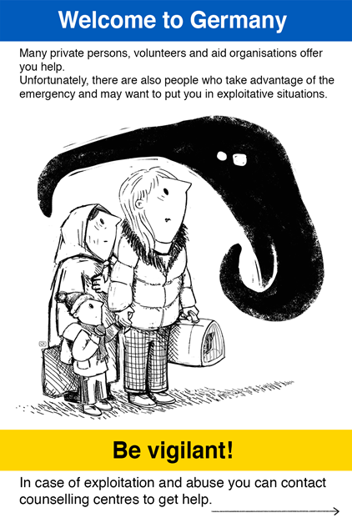

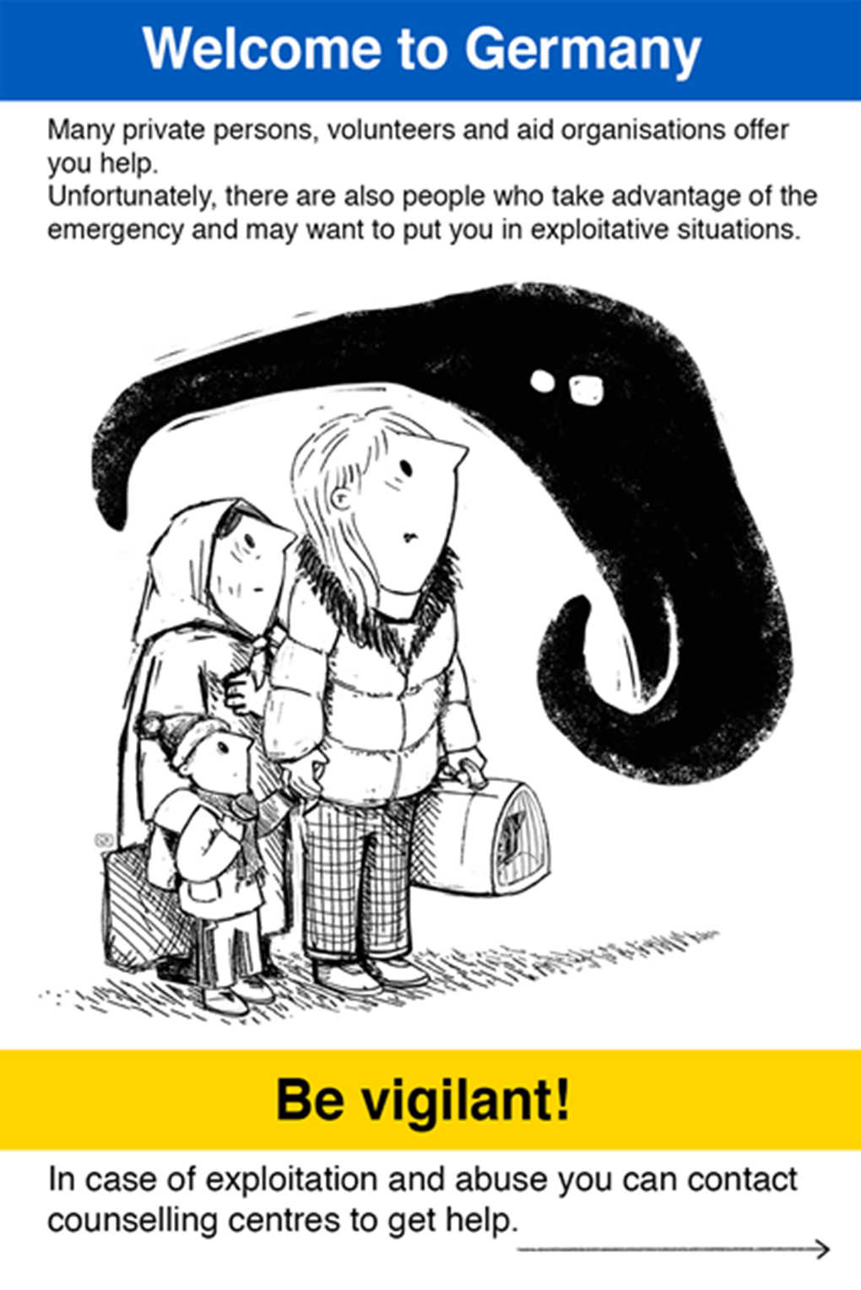

Be vigilant!
- Never give your passport and mobile phone to other people for safekeeping
- Take a picture of your passport and send it to your family
- Remember: Counselling and help about residency or social matters are free of charge in Germany
- Inform your families or friends where you are going or staying
- Be sceptical if you are offered work as soon as you arrive
- Leave your accommodation or home if you do not feel safe there
- Be sceptical if you are asked for money or pressured to do something you do not want to do
In the event of acute danger or suspicion, contact the police and dial 110!

If you have the feeling that someone wants to exploit your emergency situation, you can contact the following counselling centres free of charge in XX:
XX
XX
For counselling centres in other regions of Germany consult:

https://www.kok-gegen-menschenhandel.de/en/kok/specialised-counselling-centres

Be vigilant!
- Never give your passport and mobile phone to other people for safekeeping
- Take a picture of your passport and send it to your family
- Remember: Counselling and help about residency or social matters are free of charge in Germany
- Inform your families or friends where you are going or staying
- Be sceptical if you are offered work as soon as you arrive
- Leave your accommodation or home if you do not feel safe there
- Be sceptical if you are asked for money or pressured to do something you do not want to do
In the event of acute danger or suspicion, contact the police and dial 110!

If you have the feeling that someone wants to exploit your emergency situation, you can contact the following counselling centres free of charge in XX:
XX
XX
For counselling centres in other regions of Germany consult:

https://www.kok-gegen-menschenhandel.de/en/kok/specialised-counselling-centres

Be vigilant!
- Never give your passport and mobile phone to other people for safekeeping
- Take a picture of your passport and send it to your family
- Remember: Counselling and help about residency or social matters are free of charge in Germany
- Inform your families or friends where you are going or staying
- Be sceptical if you are offered work as soon as you arrive
- Leave your accommodation or home if you do not feel safe there
- Be sceptical if you are asked for money or pressured to do something you do not want to do
In the event of acute danger or suspicion, contact the police and dial 110!

If you have the feeling that someone wants to exploit your emergency situation, you can contact the following counselling centres free of charge in XX:
XX
XX
For counselling centres in other regions of Germany consult:

https://www.kok-gegen-menschenhandel.de/en/kok/specialised-counselling-centres

Be vigilant!
- Never give your passport and mobile phone to other people for safekeeping
- Take a picture of your passport and send it to your family
- Remember: Counselling and help about residency or social matters are free of charge in Germany
- Inform your families or friends where you are going or staying
- Be sceptical if you are offered work as soon as you arrive
- Leave your accommodation or home if you do not feel safe there
- Be sceptical if you are asked for money or pressured to do something you do not want to do
In the event of acute danger or suspicion, contact the police and dial 110!

If you have the feeling that someone wants to exploit your emergency situation, you can contact the following counselling centres free of charge in XX:
XX
XX
For counselling centres in other regions of Germany consult:

https://www.kok-gegen-menschenhandel.de/en/kok/specialised-counselling-centres

